Digital Window Jacob Smith

[Jsmith2021@brandeis.edu](mailto:Jsmith2021@brandeis.edu)

Rasberry Pi Digital Window Project

Programs and setup for a series of digital windows that will allow the makerlab to communicate internally with itself

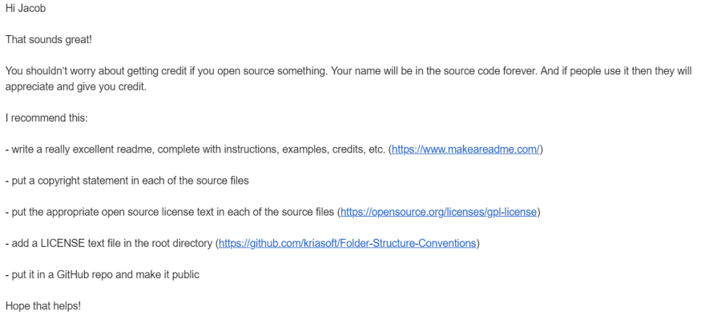

Useful commands for internet

Hostname-I to get IP address: <https://www.raspberrypi.org/documentation/remote-access/ip-address.md>

Ifconfig to get mac address: <https://www.raspberrypi-spy.co.uk/2012/06/finding-the-mac-address-of-a-raspberry-pi/>

These links show how to connect a webcam and run a server

Overall Tutorial

<https://www.instructables.com/id/How-to-Make-Raspberry-Pi-Webcam-Server-and-Stream-/>

Webcam usage

<https://www.raspberrypi.org/documentation/usage/webcams/>

Register rasberry pi brandeis open wifi network<https://netreg.brandeis.edu/index.php>

Download noobs rasberry pi

<https://www.raspberrypi.org/documentation/installation/noobs.md>

(TOP) Documentation from Professor Salas

June 17 2019 Jacob Smith 4:07 PM: I am using a rasberry pi to run a live viewing server, which can help with publicity for the Arduino Outreach program

These links are to use the rasberry Pi

Getting Started

<https://projects.raspberrypi.org/en/projects/raspberry-pi-getting-started/5>

FAQ [https://www.raspberrypi.org/documentation/faqs/#networking](https://www.raspberrypi.org/documentation/faqs/" \l "networking)

A related project would be to use the rasberry pi to tweet a picture of the room every week:

Tweeting and taking picture tutorial

<https://projects.raspberrypi.org/en/projects/the-all-seeing-pi>

Just Tweeting tutorial

<https://projects.raspberrypi.org/en/projects/getting-started-with-the-twitter-api/8>

Scheduling a task in python:

<https://stackoverflow.com/questions/373335/how-do-i-get-a-cron-like-scheduler-in-python>

I talked to H about these ideas, and she suggested a doorbell feature. This means that by the end of this project, there will be monitors displaying live feeds of the makerlab rooms with some additional displays in the lobby, and the user can go to a website to view the streams or ring a doorbell in person.

This could then be connected to existing PIR sensors in used rooms to display when there is a person there (Daniel Lays idea).

While setting up the rasberry pi, I got an input/output error, which showed me that the Rasberry Pi uses its sd card as its storage so it must have an sd card in at all times. <https://www.raspberrypi.org/forums/viewtopic.php?t=26715>

6:21 PM: The secret to download noobs on previous page is to copy contents of noobs folder to sd card.

6/18/2019 11:18 Am Jacob Smith: I set time on Rasberry Pi using startup menu, and went to Brandeis ITS help desk to handle the MAC address registration on Brandeis Open (see page 102 of Zumo notebook)

4:49 PM: I spent today looking through functions on the Rasberry Pi.   
I can now tweet, read button presses, and take pictures from the rasberry Pi.

Some Errors I got along the way where

A folder not found error when the webcam was not plugged in

<https://forum.arduino.cc/index.php?topic=424233.0>

A parsing error with Python because methods need to be declared before they are called

<https://stackoverflow.com/questions/3754240/declare-function-at-end-of-file-in-python/3754284>

A server rejected error when remotely accessing IP address, Brandeis ITS gave me a secure file transfer protocol datasheet.

[https://www.ssh.com/ssh/putty/putty-manuals/0.68/Chapter10.html#errors-connrefused](https://www.ssh.com/ssh/putty/putty-manuals/0.68/Chapter10.html" \l "errors-connrefused)

Python blocks need one element in body<https://stackoverflow.com/questions/43189302/syntaxerror-unexpected-eof-while-parsing?rq=1>

Defining a python function <https://www.tutorialspoint.com/python/python_functions.htm>

<https://www.codementor.io/kaushikpal/user-defined-functions-in-python-8s7wyc8k2>

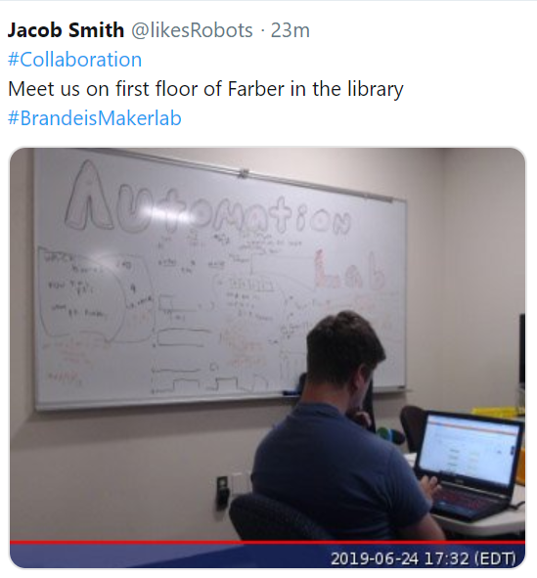

Jacob Smith 6//21/2019 (Backlog of documentation)

<-**-This is the Twitter.py python program I wrote to: load my twitter account information, and tweet a newly taken picture when a button is pressed.**

The tweet also includes a randomly selected message such as #collaboration.

The programs are modified from existing tutorials.

In this version, I am importing code in a method instead of at the top as I would in java, which is bad practice.

Error messages I encountered are presented here and on the next page

**Tweet Generated fromTwitter.py Python program**

While loop in python <https://www.tutorialspoint.com/python/python_while_loop.htm>

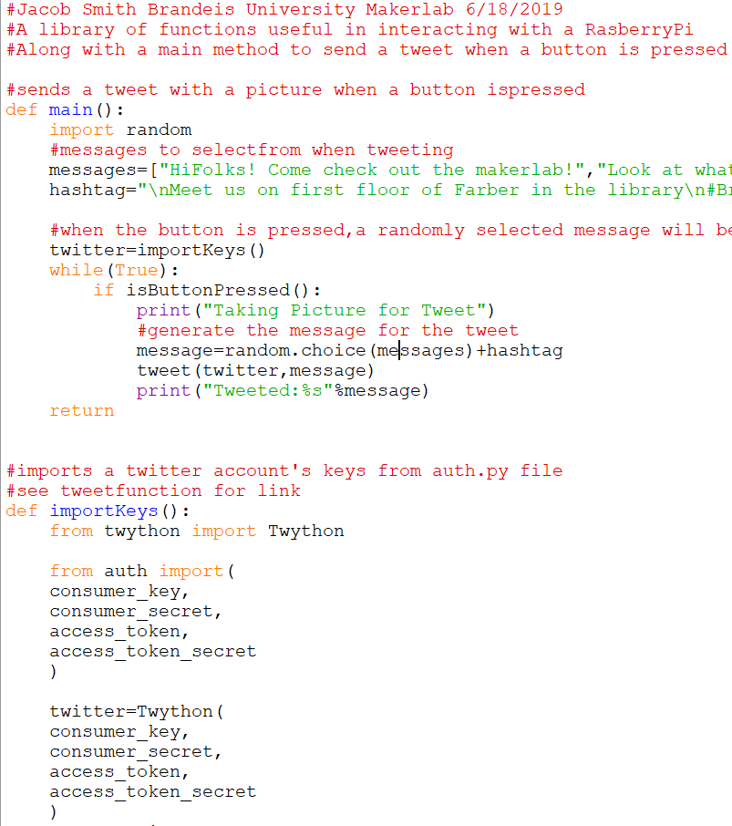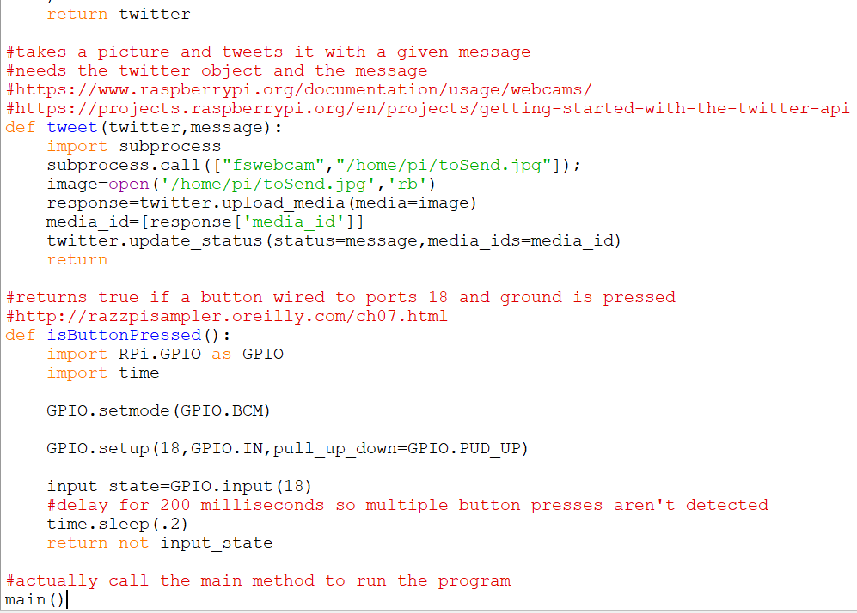

Run a bash script in python

<https://unix.stackexchange.com/questions/190495/how-to-execute-a-bash-command-in-a-python-script>

File Paths for imaging <https://stackoverflow.com/questions/11727598/pil-image-open-working-for-some-images-but-not-others>

Sleeping in Python

<https://stackoverflow.com/questions/510348/how-can-i-make-a-time-delay-in-python>

Randomly Select element from a list python

<https://stackoverflow.com/questions/306400/how-to-randomly-select-an-item-from-a-list>

Python whitespace error <https://stackoverflow.com/questions/26720841/python-indentationerror-unindent-does-not-match-any-outer-indentation-level/34100174>

Jacob Smith 10:20 AM 6/19/2019: I am continuing on the Rasberry Pi Webserver and tweeting project, I connected to the ip address now, it was the broadcast ip address, I was using the inet ip address-->

<https://www.raspberrypi.org/forums/viewtopic.php?t=172891>

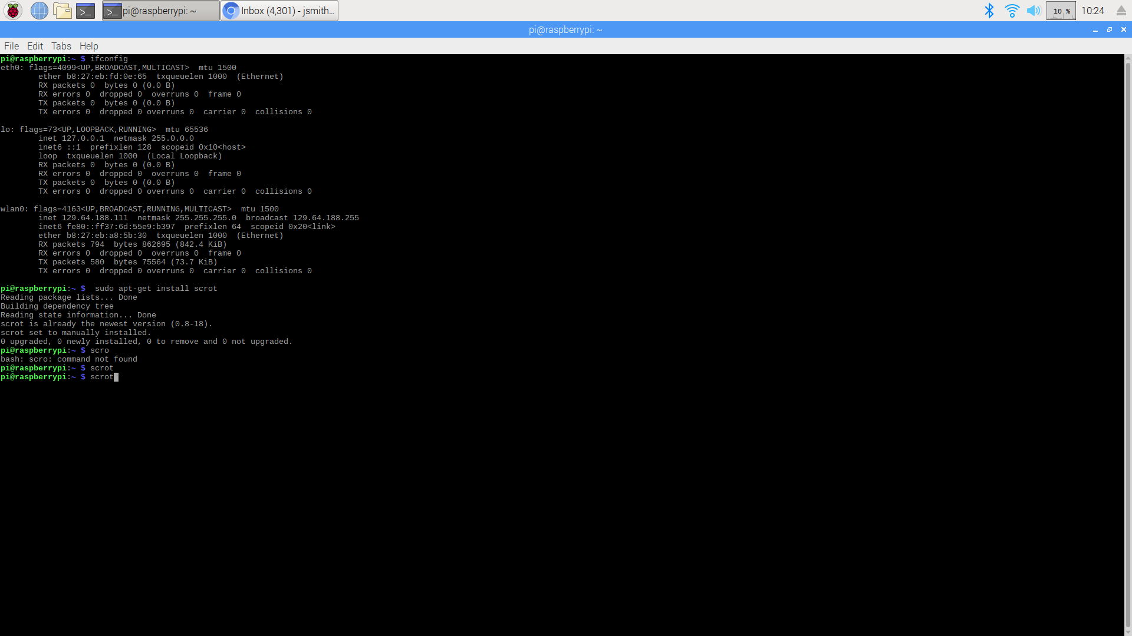

Result of ifConfig command in rasberry Pi, with correct IP adress for remote access highlighted

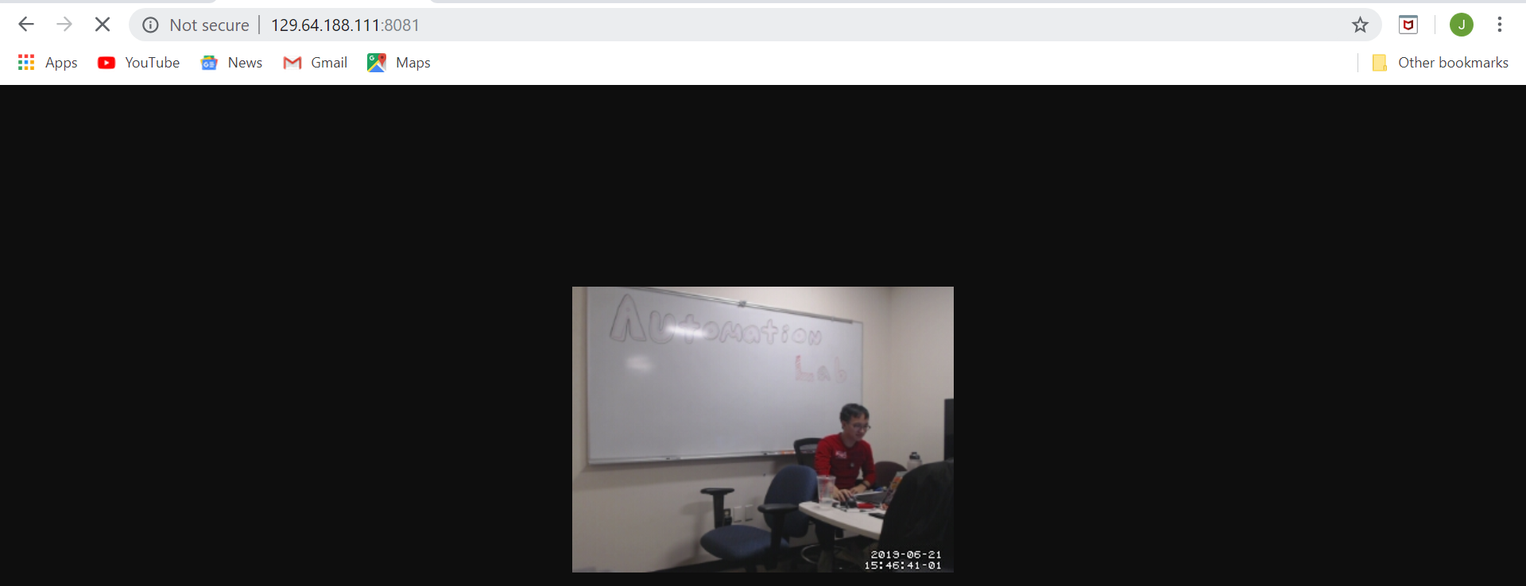

6/21/2019 1:02 PM Jacob Smith

I got fswebcam to display the server, using Tims help with step 6. That step involved using the Rasberry Pi Terminal to find the configuration file and editing it.

I needed to learn more about Linux commands<http://linuxcommand.org/lc3_lts0020.php>

Another command that was necessary was how to stop the motion stream:<https://ubuntuforums.org/showthread.php?t=2145787>

**Output of fswebcam server**

]

Unfortunately, the video is about one frame per second, which is the same as this post : <https://raspberrypi.stackexchange.com/questions/29543/motion-filming-cant-get-on-real-speed>, which recommends MJPEG

I tried using MJPEG

<https://blog.miguelgrinberg.com/post/how-to-build-and-run-mjpg-streamer-on-the-raspberry-pi>

MJPG Streamer download: [https://github.com/jacksonliam/mjpg-streamer](https://github.com/jacksonliam/mjpg-streamer" \l "inbox/_blank" \t "https://mail.google.com/mail/u/0/)

This results in a address already in use message, which seems that the other webserver I started isnt closing

In addition, this forum claims to have a high enough frame rate to control a robot from the feed:

[https://www.raspberrypi.org/forums/viewtopic.php?p=751735](https://www.raspberrypi.org/forums/viewtopic.php?p=751735" \l "inbox/_blank" \t "https://mail.google.com/mail/u/0/)

The tutorial resulted in a error opening V4L interface error,

**See Right-->**

[https://raspberrypi.stackexchange.com/questions/77768/error-opening-v4l-interface-no-such-file-or-directory](https://raspberrypi.stackexchange.com/questions/77768/error-opening-v4l-interface-no-such-file-or-directory" \l "inbox/_blank" \t "https://mail.google.com/mail/u/0/)

However, this stream is also very slow

I looked for other streaming platforms than motion, and tried this tutorial:

<https://chriscarey.com/blog/2017/04/30/achieving-high-frame-rate-with-a-raspberry-pi-camera-system/>

But it resulted in a failed to create component vc.ril.camera message

**Below ↓** is an example of the feed not working

LEFT: Error with one of web server commands shows blank picture

RIGHT: Error when using streamer.sh

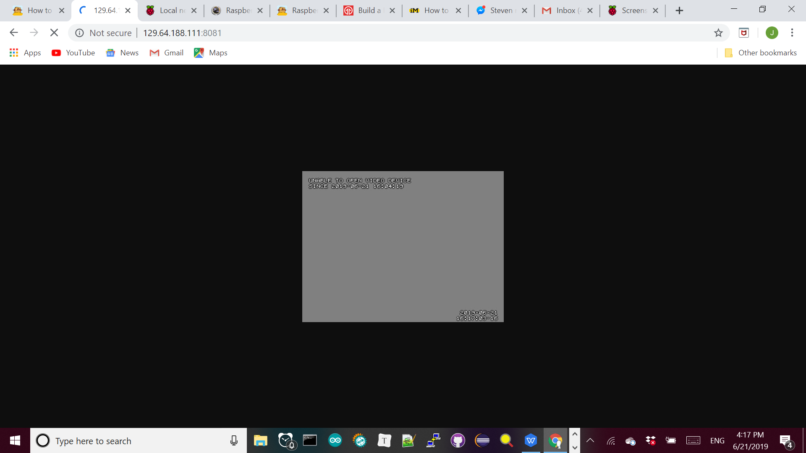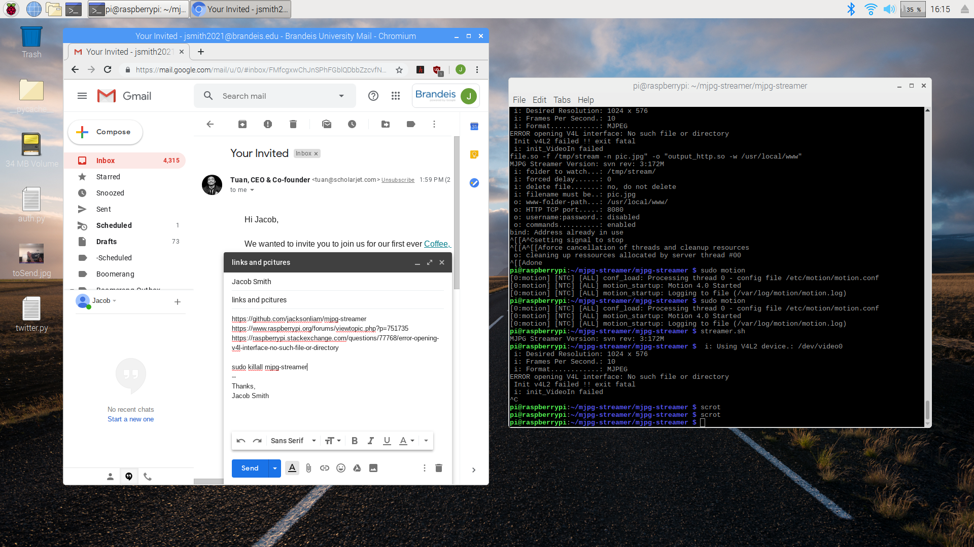

Jacob Smith 6/25/2019 5:41 PM: I think the previous high frame rate tutorial is for rasberry pi camera

2012/5/7 post shows camera needs yuyv format:<https://sourceforge.net/p/mjpg-streamer/discussion/739917/thread/dfc46d26/>

6/26/2019 12:02 PM Jacob Smith: yesterday, I got the web stream to work at 60 frames per second!

First, I followed this tutorial to get the stream to work at all <https://blog.cudmore.io/post/2015/03/15/Installing-mjpg-streamer-on-a-raspberry-pi/>

Then, I used this: 2010/4/8 :<https://sourceforge.net/p/mjpg-streamer/discussion/739917/thread/541a9b8c/> to change the frame rate from 6 fps to 60 fps.

**The stream and command line results are shown right and bottom (note highlight box showing framerate)-->**

The next goal is to allow streaming with audio and video, and YUYV can’t do that.

The Logitech c290 camera I am using supports the h264 video format, which includes audio

<https://raspberrypi.stackexchange.com/questions/4412/streaming-h264-with-logitech-c920>

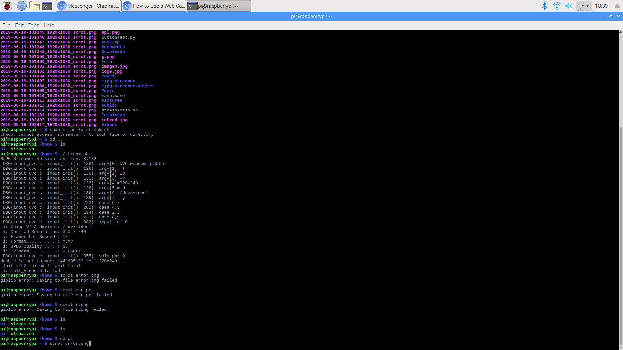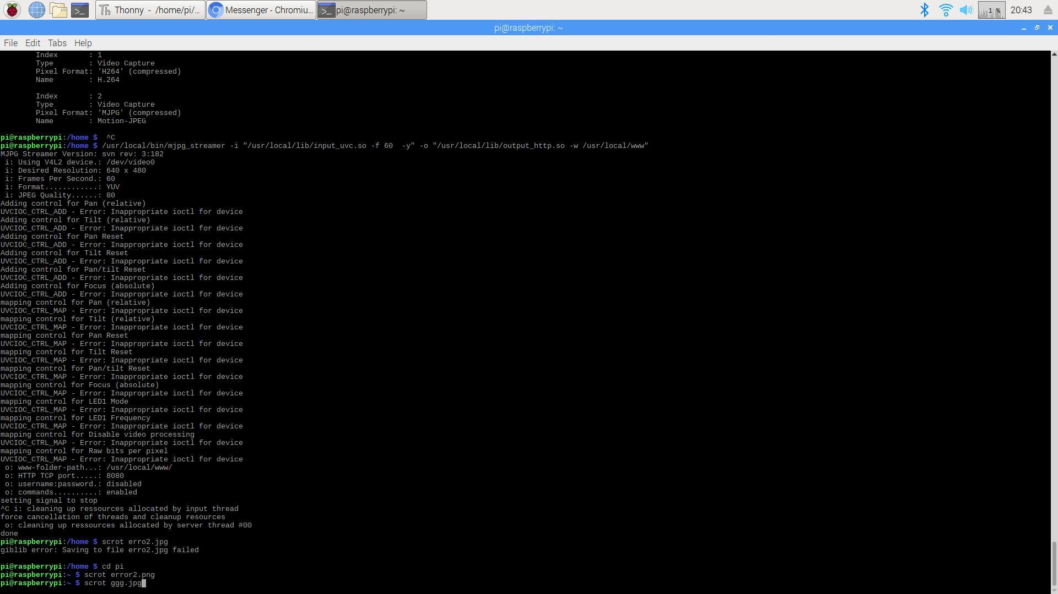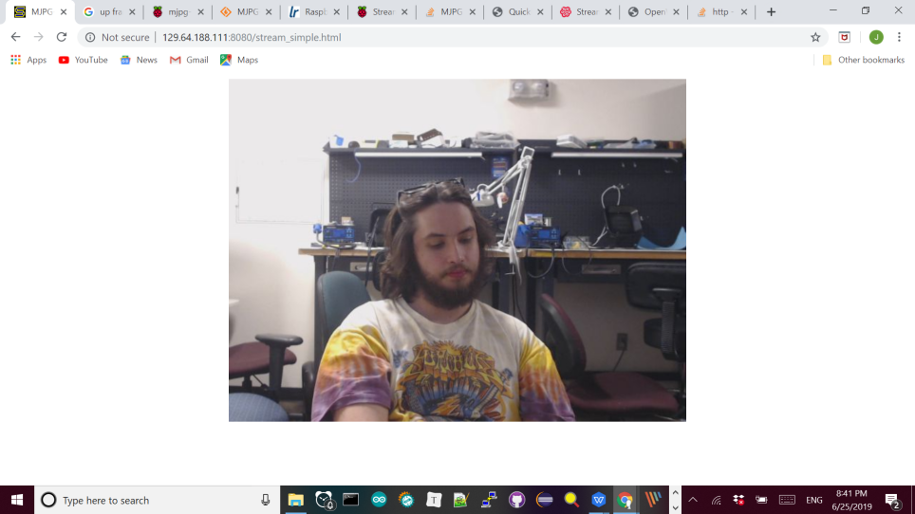

(TOP)yuyv format spec

(LEFT)working mjpg stream at 60 fps 129.64.188.111:8080/stream\_simple.htm

(BOTTOM)message showing success